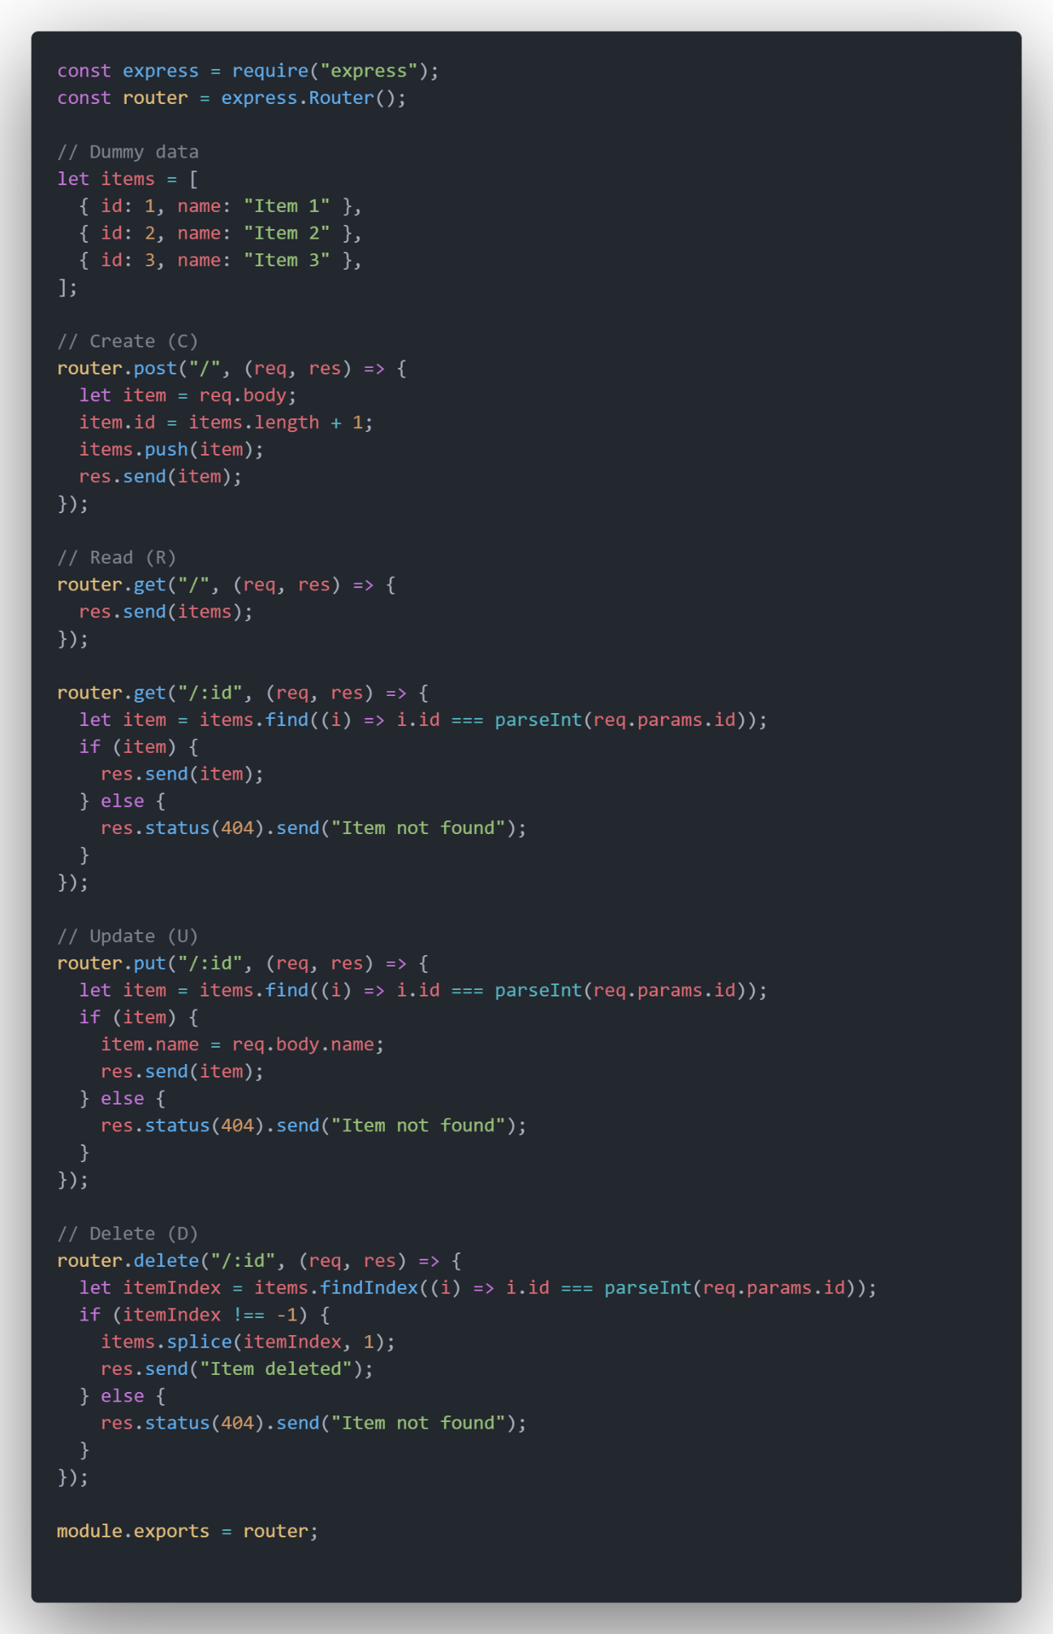

## Código

const express = require("express");

const router = express.Router();

// Dummy data

let items = [

  { id: 1, name: "Item 1" },

  { id: 2, name: "Item 2" },

  { id: 3, name: "Item 3" },

];

// Create (C)

router.post("/", (req, res) => {

  let item = req.body;

  item.id = items.length + 1;

  items.push(item);

  res.send(item);

});

// Read (R)

router.get("/", (req, res) => {

  res.send(items);

});

router.get("/:id", (req, res) => {

  let item = items.find((i) => i.id === parseInt(req.params.id));

  if (item) {

    res.send(item);

  } else {

    res.status(404).send("Item not found");

  }

});

// Update (U)

router.put("/:id", (req, res) => {

  let item = items.find((i) => i.id === parseInt(req.params.id));

  if (item) {

    item.name = req.body.name;

    res.send(item);

  } else {

    res.status(404).send("Item not found");

  }

});

// Delete (D)

router.delete("/:id", (req, res) => {

  let itemIndex = items.findIndex((i) => i.id === parseInt(req.params.id));

  if (itemIndex !== -1) {

    items.splice(itemIndex, 1);

    res.send("Item deleted");

  } else {

    res.status(404).send("Item not found");

  }

});

module.exports = router;